**Surface Approximation Tools User Manual**

* Installation
* Create Toolbar & Commands
* Operation procedure
* Error handling
* Documentations

**Installation**

The “VBAProject1.catvba” file is an integrated file, which contains all the macros needed to do the implementation. The users should load this file in CATIA by open it in Visual Basic Editor (Tools 🡪 Macros 🡪 Visual Basic Editor)

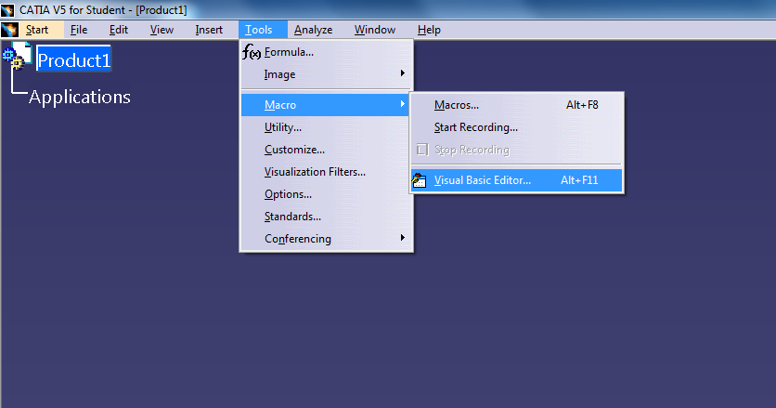

If there is no other projects loaded in the VB Editor, click “yes” if CATIA asks whether open or create a new one. Then, add the “VBAProject1.catvba” file in.

If there are other projects loaded, import the project from “file“ –> “import file”

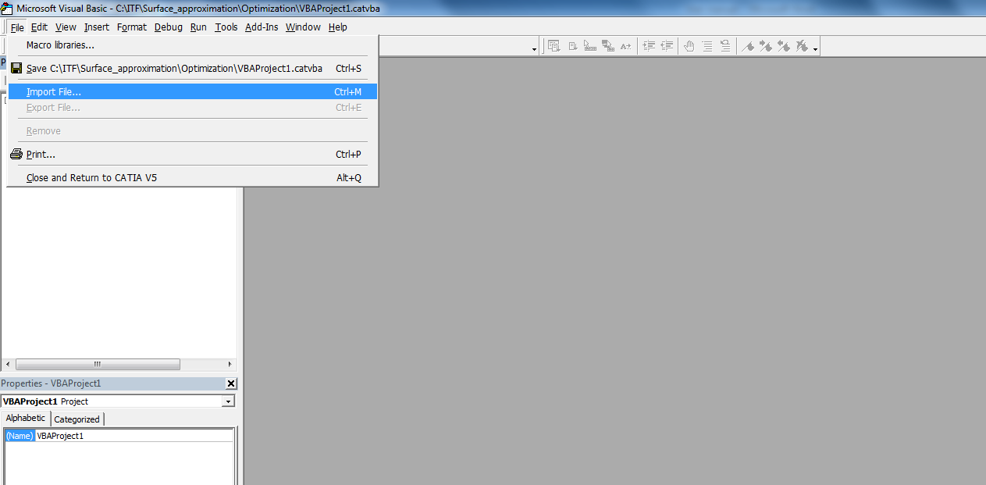

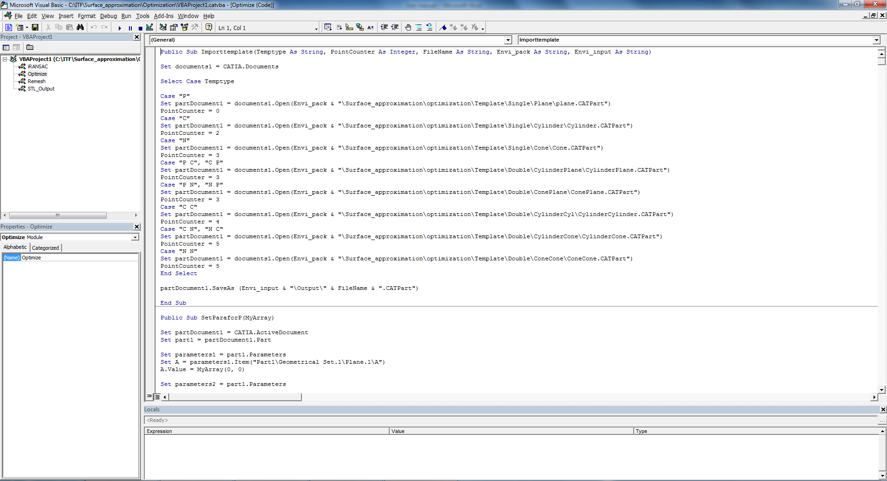

**Create Toolbar & Commands**

1. Add "Surface approximation" toolbar to “Generative Shape Design” workbench.  
     
   1.) Click [Tools --> Customize...], Select Toolbars from tab menu.  
   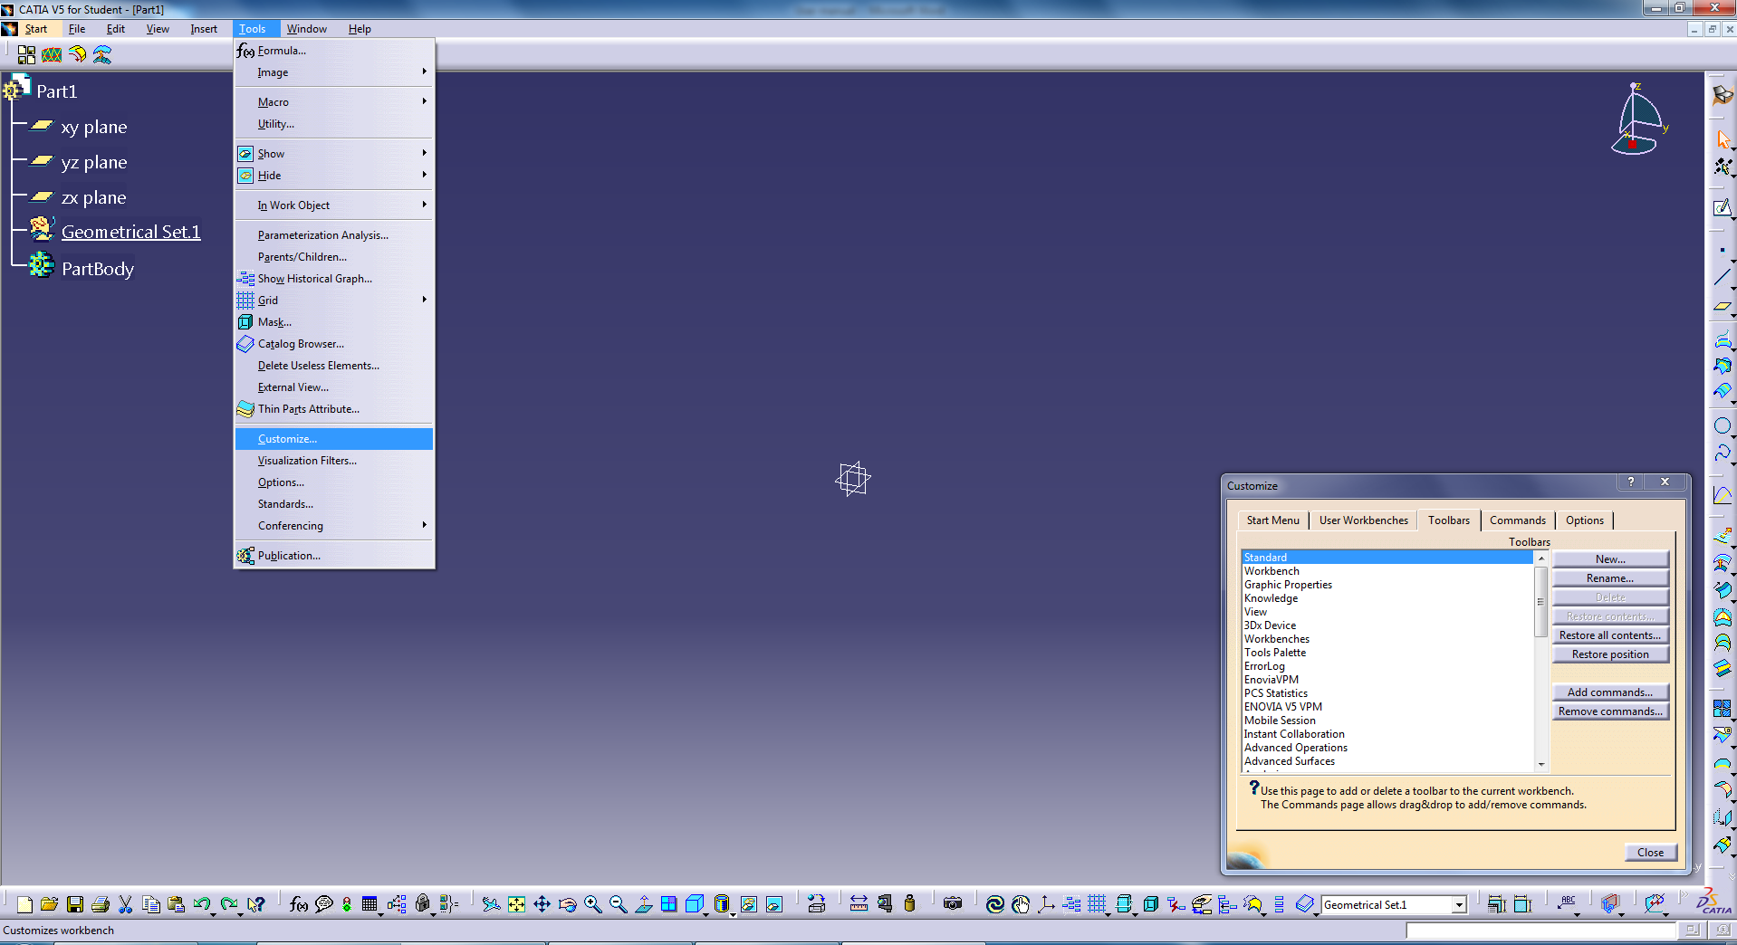  
   2.) Click "News...", input " Surface approximation " as Toolbar Name.  
   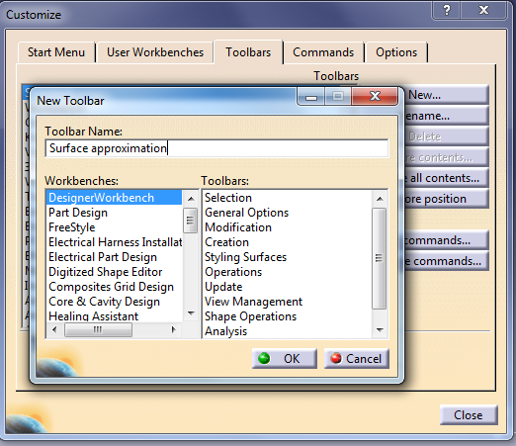  
   3.)An empty tool bar was created.
2. Add Macros to the toolbar.  
     
   1.) Click [Tools --> Customize...], Select Commands from tab menu.  
     
   2.) Select Macros from categories.  
   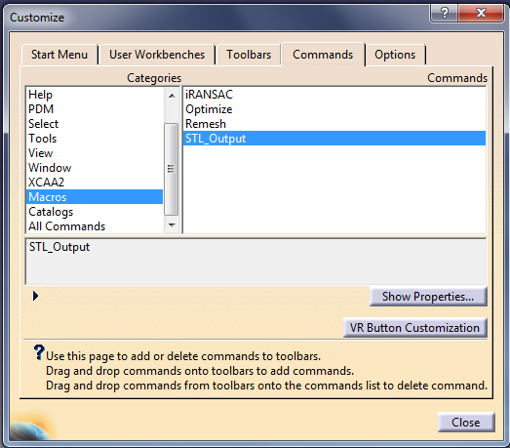  
   3.) Choose "STL\_ouput", click "show Properties".   
     
   4.) Click [C:\Users\AMI\Downloads\Catia_API UserGuide-20180725T053832Z-001\Catia_API UserGuide\image\icon_icon.jpg], locate []; Pick it.   
     
   5.) Drag and drop the " STL\_ouput " onto the tool bar.

6). Repeat the 3)-5) for the Remesh , iRANSAC  and Optimize 

1. Result



**Operation procedure**

The whole system is integrated as one project and built in CATIA. After loading the whole project and installing the necessary packages, the users should be able to create a toolbar which contains four functions(macros): pre-process, remesh , iRANSAC and optimization.  These four macros could be related to icons and run from the GUI. Before running the program, the user should prepare the input CAD file. Inside CAD file, all the models(surfaces) should rest under the Geometrical Set branch (“Geometrical Set.1”) of the specification tree. With the input file prepared, the user could run macros one by one. The pre-process function will export each surface from the CAD file and save them as .CATPart and .stl format. The CATIA Part files can be found in a folder named as “input” under the same directory as the input CAD file. With the appearance of dialog box "The selected surfaces are all exported! Please click 'OK' to proceed! ", the user could run the next macro named as “remesh”. The macro will call the remesh.exe and complete the remesh procedure. Then, the iRANSAC macro should be executed and meanwhile the user can run the optimization macro. Generally speaking, each surface will take 5 mins to process. After the optimization done, the dialog box will tell the user the amount of file failed to process, and under this case, the user should change the remesh parameters in text file and rerun the last three macros.

**Error handling**

if the error happens in iRANSAC stage, it is probably because the flaws in algorithm. The program will automatically collect all the error files and put them in a new folder. What the user should do is change the parameters of remesh and redo the process for the error files.

If the error happens in optimization, a “report” file will be generated, writing the information for each file: success or fail? if fail, at which stage it failed?

**Documentation**

Herein, the workflow of this proposed approach in CATIA runs like this: a set of pre-built templates need to be stored in the certain location. The total amount of templates in the current library is 8, 3 for single patch and 5 for double patch. The main macro will search and detect the text files generated by RANSAC. Once finding an available text file to process, it will call the optimization macro. The optimization macro consists of four parts: text file reading, setting initial parameters, optimization and post-process. The output of optimization macro is the processed CAD file saved in the output folder and also a report contains the necessary information of  the processing,

The first part of optimization macro is text reading. The text file is the output from iRANSAC process, in which it writes the type of surface recognized by RANSAC, the parameters of the patch, the mesh points belonging to that patch and also the boundary points.  As illustrated in the section above, the content of text file writes in a modular way so that the optimization macro could import all the contained information nice and neat. During the text file reading, The template file will be opened correspondingly and saved as a new copy. The parameters of each patch is stored in a 2-Dimensional array. While reading the coordinates of point clouds, each point will be created and suspended one by one, and the distance between each point and template will be measured and stored as parameters in the file. The objective function is the sum of square of each distance. The distance parameter is a dynamic data format so that the objective function could be updated during the optimization.

The second part is setting parameters for the template. Basically, different template should have a different way to set the parameters. To simplify this process, the patch is manually given a sequence and rank from priority to inferiority in this way: cylinder, cone and plane. The reason for this sequence is because the template constructed first have more DOF and is considered as the primary one. The template construction method will be illustrated in the 2.3.2 section. When each double-patch template , there is a mirror symmetric one. Therefore, an additional judgement is a must. Also, for cylindrical-conic,  cylindrical-cylindrical, conic-conic template, the two patch could be both concave or one concave and one convex. Thus the orientation of the patch should be assessed in the program. For double patch cases, the buffer zone will be considered and reexamined due to the greedy nature of RANSAC algorithm. The buffer zone will be divided into 20 strips and for each of them the variation of template to original points will be calculated. After this searching process, the best initial solution will be found.

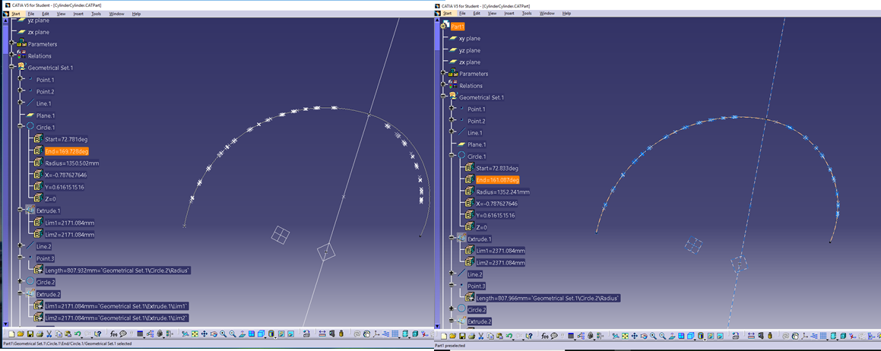

Figure 13 Template before buffer zone search vs template after buffer zone search

The third part is optimization. This part is to set up the CATIA optimizer and this process is done in the “Knowledgeware” →”Product Engineering Optimizer” workbench. .

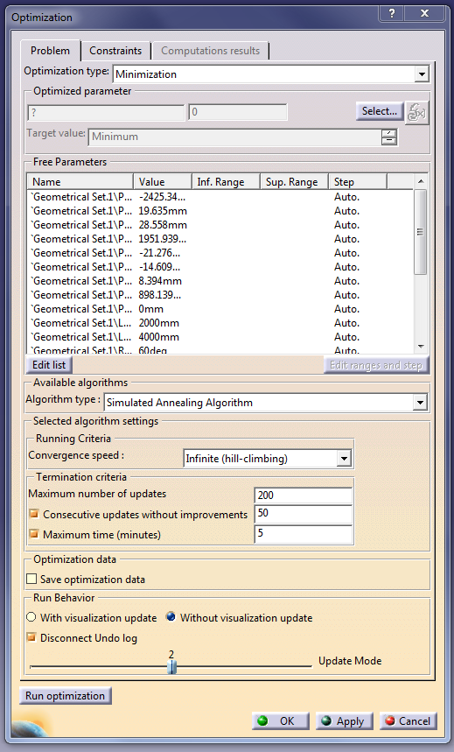

Figure 14 Optimization setup

The optimized parameter is the objective function measuring the variation from sampling points to the template, which should be minimized during the optimization process.  The free parameters are those parametric values defining the shape and position of the template, and they are listed in the template construction part. The algorithm chosen here is the Simulated Annealing Algorithm [reference], and the converging speed is set to infinite climbing since the RANSAC output is already a feasible  solution. The termination criteria varies form template to template, depending on the number of free parameters

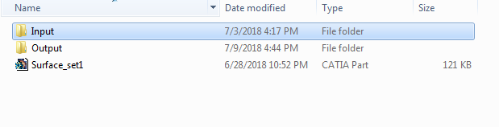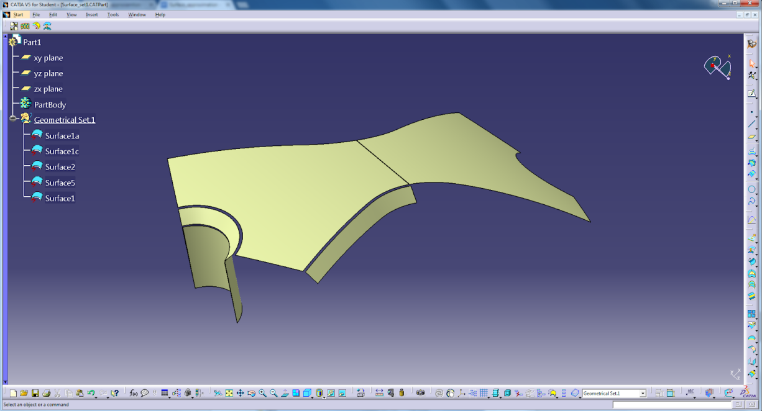

Input folder

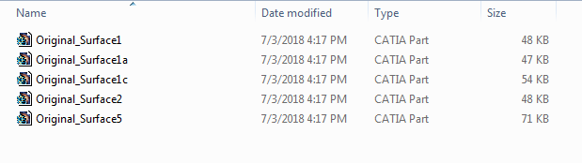

Intermediate folder, under “ITF:\Surface\_approximation\Examples\”

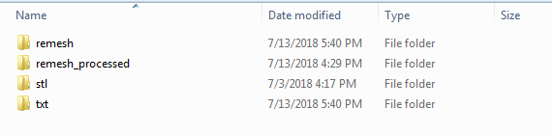

Output folder

